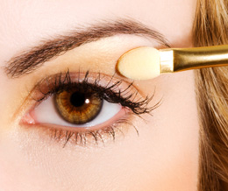
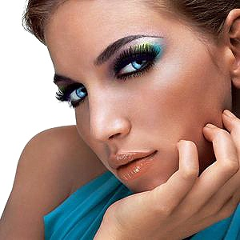
Beauty Salon
Master Place of
Master Mind People


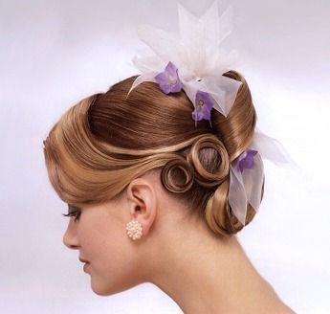
Special 10%

Discount Offer on
- Make up
- Hair style
- Facial of 4 kinds
- Mask
- Plucking
- Manicure & Pedicure
Join Us from 30 July 2025 at
Place name, city name, state
Contact Us: 555-555-5555

